**Use Case**

This employee handbook outlines employment basics for the organization.

**Contents**

* Employment contract types
* Recruitment and selection process
* Attendance

## **Ecosystem**

The learning ecosystem includes three items.

*Ecosystem – Company Policy, Video, and Consultation Session*

## **Video**



The actor, verbs, and object for the video.

|  |  |
| --- | --- |
| **Verb** | **Notes** |
| Played | Indicates that the actor started experiencing the recorded media object. |
| Seeked | Indicates that the actor changed the progress towards a specific point. |
| Interacted | Indicates that the actor muted the player. |
| Completed | Indicates that the actor completed the video by watching all parts of the video at least once. |
| Paused | Indicates that the actor temporary or permanently stopped experiencing the recorded media. |

The following result extensions can be added to the statement:

|  |  |
| --- | --- |
| **Extension** | **Notes** |
| Time | Used to express the time into the video. |
| Time From / Time To | Used to identify the point in time the actor changed from in a media object during a seek operation. |
| Progress | Used to express the percentage of media consumed by the actor. |

## **PDF**

The actor, verbs, and object for the .pdf file.

|  |  |
| --- | --- |
| Open | Open .pdf file. |
| Experience | * One Yes text field to indicate a Consultation Experience. * Two name text fields to identify the actor and the actor’s manager. |

Field Name:

yesConsultationCompleted

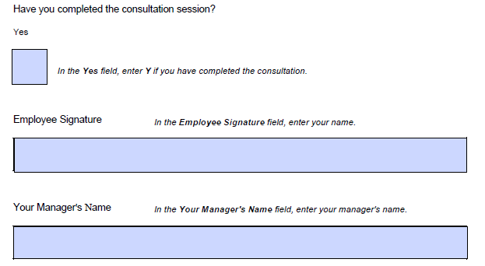

Field Name:

managerName

Field Name:

employeeSignature

Each member of a hiring team might have different responsibilities (for example, recruiters will source interview candidates, while hiring managers will interview candidates).

Throughout this process, we aim to keep candidates informed, communicate well, and give everyone an equal opportunity to work with us. Ask our recruiters for help whenever you need to enhance candidate experience or write an inclusive job description.

### **Background Checks**

If you want to [run background checks](https://resources.workable.com/background-check-policy) on candidates, ask HR for guidance. This process is sensitive, and we must always abide by laws and ensure candidates understand our intentions. For best practices, commission a background check for finalists only. Use our contracted provider and ensure you have your candidates’ permission.

### **Referrals**

If you know someone who you think would be a good fit for a position at our company, feel free to refer them. If we end up hiring your referred candidate, you are eligible for a referral bonus.

Additional rules for rewards:

* We guarantee that rewards will be paid out within a month of the date of candidates’ hire date.
* There is no cap on the number of referrals an employee can make. All rewards will be paid accordingly.
* If two or more employees refer the same candidate, only the first referrer will receive the referral incentives.
* Referrers are still eligible for rewards even if a candidate is hired in the future or is hired for a different position.

### **Who Can Be Referred?**

We have two conditions for candidates who can qualify you for our rewards. They should:

* Have not applied to our company for at least a year.
* Be hired as permanent full- or part-time employees (not as temporary employees or contractors).

Our company may use an online form or a platform where employees may refer candidates. You can also reach out directly to the Talent Manager of Acquisition with referrals.

Generally, we encourage you to check our open positions and consider your social networks and external networks as potential resources for referred candidates.

Keep in mind that rewards may be subject to taxation. Please contact HR or our referral program manager for more information.

## **Attendance**

We expect you to be present during your [scheduled working hours](https://resources.workable.com/attendance-company-policy). If you face an emergency that prevents you from coming to work one day, contact your manager.

Have you completed the consultation session?

Yes

|  |
| --- |
|  |

Employee Signature

|  |
| --- |
|  |

Manager Signature

|  |
| --- |
|  |